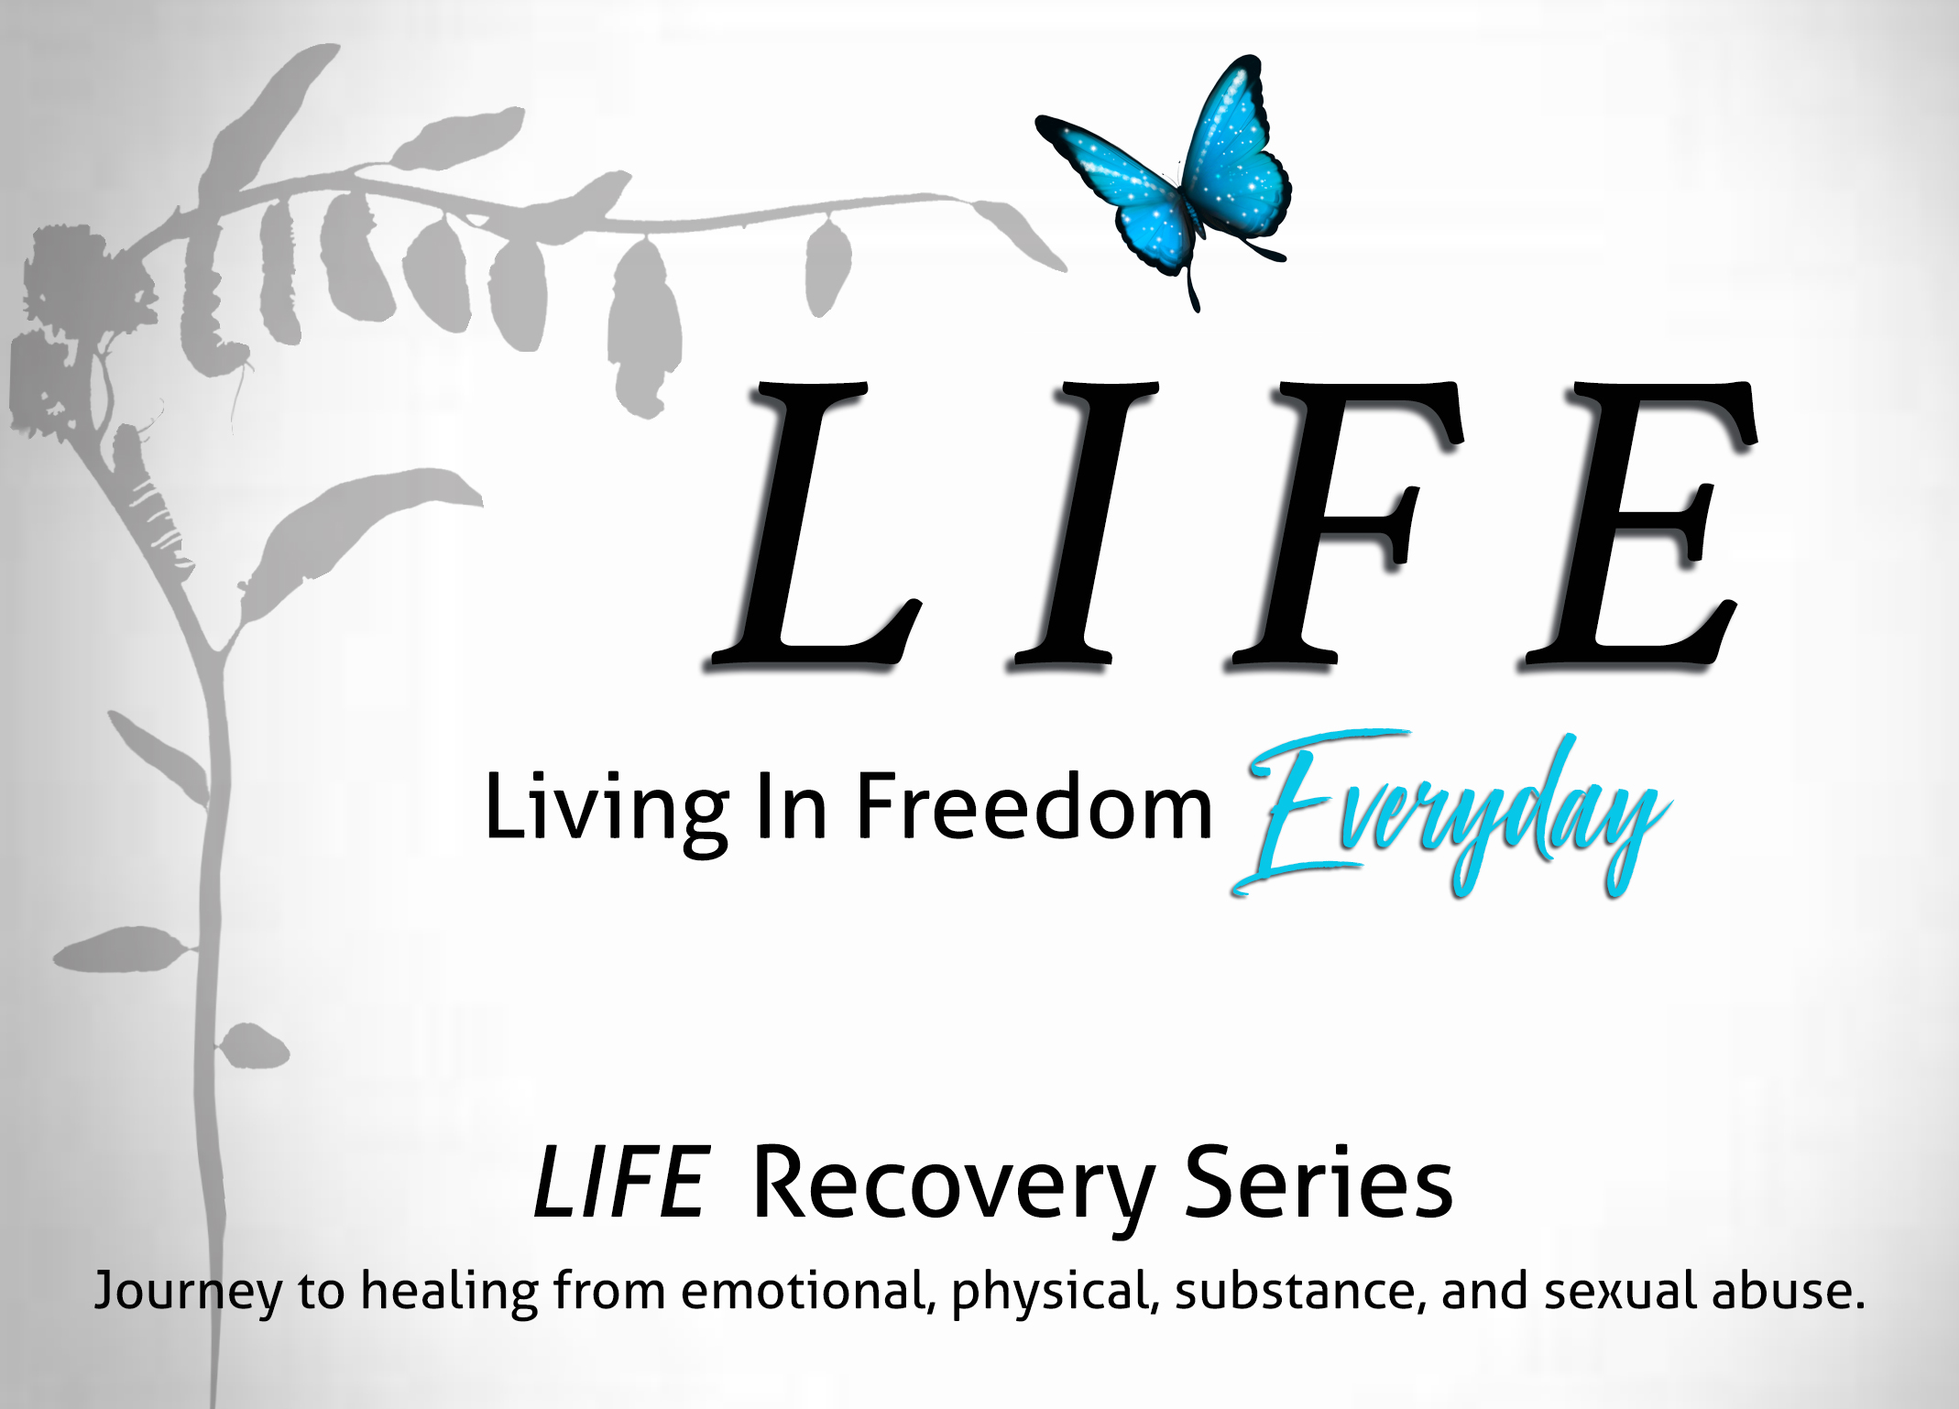

LIFE Recovery Series

Living In Freedom EVERYDAY!
Recovery for Damaged Emotions
LIFE (Living In Freedom EVERYDAY) Recovery Series is an educational tool used in the Recovery for Damaged Emotions. This series examines the 5 stages of healing and the damaged emotions within each healing stage. In combining basic knowledge of how our 3-part brain functions, and scripture-based knowledge, we gain a clarity and understanding when we are confronted with life’s hurts and abuses. When scripture-based knowledge and neuroscience is looked upon as a whole, there is something transformational that happens not only in our mind but in our spirit as well. Life at times can be extremely complex and within these complexities of life come hurts and abuses. Hurts and abuses leave a trail of damaged emotions. Damaged emotions when left unattended, suppressed, and buried become toxic and destructive.
I have come that you might have life and have it more abundantly.
John 10:10
The most important need of any person who has suffered hurts and abuses is… a safe environment. A physical safe environment as well as a social and emotionally safe environment. When a completely safe environment is provided, we no longer feel threatened physically and we feel safe enough socially and emotionally that we are able to express our feelings and emotions without feeling judged. Safe environments allow us to take ownership of our damaged emotions and begin to work through them, rather than allowing our emotions to control us as they continue on a toxic and destructive path.
We’ve all witnessed the person who lives life driven by damaged emotions. In fact, we may BE or HAVE BEEN that very person. The person who has the mindset of “do it unto others BEFORE they do it to you.” The person who thinks everyone is trying to outsmart them and undermined them. The person whose spirit, mind and body cannot find a safe environment to dwell. We feel a constant threat physically, socially and emotionally. We live life operating from our brainstem (fight or flight) rather than our neocortex (clarity, problem-solving, reasoning). Our damaged emotions are controlling us rather than us controlling our damaged emotions. Why live life in an excruciating painful manner when we can choose LIFE and begin Living In Freedom EVERYDAY?
Education, knowledge and research are good things. But what good are they when they stand alone? There is a wonderful transformation which takes place when we allow knowledge and scripture to connect. It validates your purpose!
Transformed by the renewing of our mind…
Romans 12:2
As we continue on life’s journey and we encounter life’s hurts and abuses, we will find that we never want this Recovery for Damaged Emotions to end.
Welcome to this journey of LIFE.
Welcome to Living In Freedom EVERYDAY!
Welcome to Recovery for Damaged Emotions.
Let the journey of LIFE begin, and may it never end!

